**NOTE**: You need a public StartUp class with the namespace Stealer.

It’s time to see what this hacker you are dealing with aims to do. Create a method inside your Spy class called - RevealPrivateMethods(string className). Print all private methods in the following format:

All Private Methods of Class: **{className}**  
Base Class: **{baseClassName}**  
On the next lines, print found method’s names each on a new line. Use **StringBuilder** to concatenate the answer**. Don’t change anything in Hacker class!** In your **Main()** method, you should be able to check your program with the current piece of code.

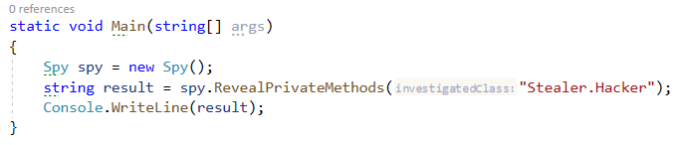

### Example

**NOTE**: **The order of your output** may **differ** based on your **solution logic**.

|  |
| --- |
| **Output** |
| All Private Methods of Class: Stealer.Hacker  Base Class: Object  get_Id  set_Id  set_BankAccountBalance  MemberwiseClone  Finalize |